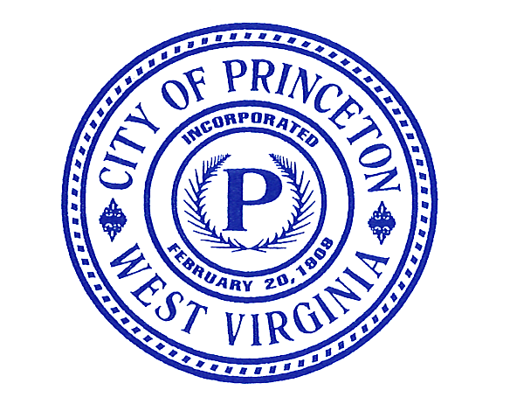

City of Princeton

CLASS I LEGAL NOTICE

ATTENTION PRINCETON RESIDENTS
SPECIAL CITY COUNCIL MEETING

On Wednesday, February 7th, 2024, at 9:00 a.m., the Princeton City Council will convene a Special Meeting in the Council Chambers of the Municipal Building, 800 Bee Street, Princeton, West Virginia, to conduct its annual Budget Planning Session for the FY 2025 General Fund Budget.
Dated this the 24th day of January, 2024
Kaitlyn Smith, City Clerk
____________________________________________________________________________
Bluefield Daily Telegraph – Please publish one time ASAP as a Class I Legal Ad. Thank you.

cc: City Council
City Manager
City Attorney
Human Resources
Bulletin Boards

800 Bee Street * Princeton, West Virginia 24740-3268
(304) 487-5020 * Fax (304) 487-5030 * www.cityofprinceton.org
 Equal Housing Opportunity

